Practical - 8
Practical Title : MySQL Schema Design, ER Model, PDO Connectivity, and Prepared Statements
Problem Definition: Design the database for StudentHub with students, events and registrations. Create PHP database connection using MYSQL statements.

Theory

Is the schema normalized properly?
Answer: Yes, the schema is properly normalized to reduce data duplication and maintain data consistency.

Are primary keys and foreign keys correctly defined?
Answer: Yes, primary keys uniquely identify records, and foreign keys correctly establish relationships between related tables.

Is the database connection handled securely?
Answer: The database connection should use secure credentials and prepared statements to protect against unauthorized access and SQL injection.

Implementation :
- Created the database and required tables.
- Defined primary keys for unique record identification.
- Added foreign keys to establish relationships between tables.
- Applied proper data types and constraints.
- Implemented secure database connection.
- Used validation and prepared statements for safer data handling.

Evidence of Work (Screenshots)
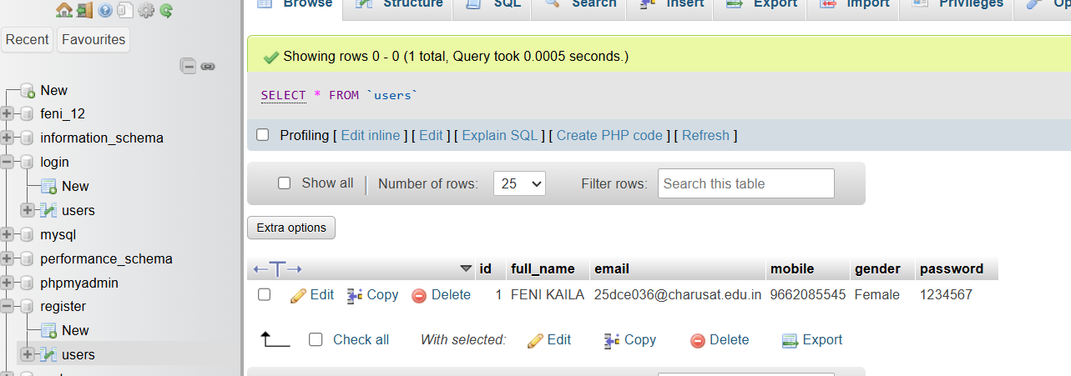
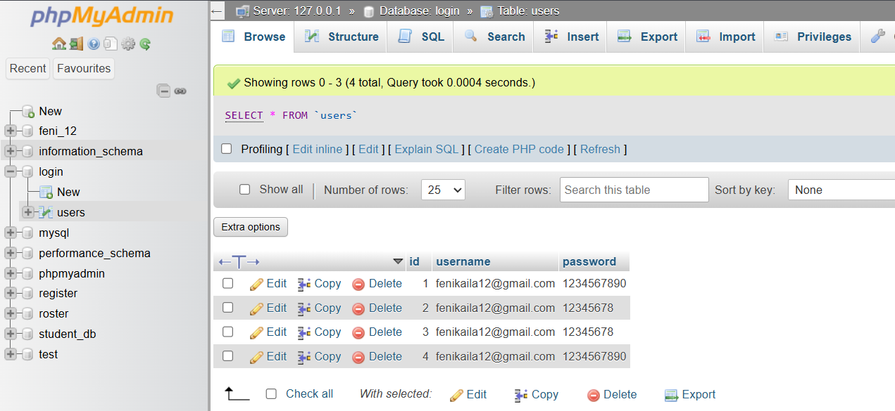

GitHub Repository Link:
https://github.com/fenikaila12/WDF/tree/main/Practical%208

Challenges Faced:
- Understanding the relationships between different tables.
- Defining correct primary and foreign keys.
- Maintaining proper database normalization.
- Handling database connection and SQL errors.

Learning Outcomes:
• Learned how to design and create a database schema.
• Understood primary keys and foreign keys.
• Learned the importance of database normalization.
• Learned how to connect an application with a database securely.
• Improved understanding of SQL queries and data management.

Faculty Remarks: (Keep this blank for faculty)

